Project Design Phase-II

Data Flow Diagram & User Stories

|  |  |
| --- | --- |
| Date | 30 October 2023 |
| Team ID | 153FEE77E2BD77F95DB47FD6C0047366 |
| Project Name | Unearthing Trends from LinkedIn Influencers |
| Maximum Marks | 4 Marks |

# Data Flow Diagrams:

A Data Flow Diagram (DFD) is a traditional visual representation of the information flows within a system. A neat and clear DFD can depict the right amount of the system requirement graphically. It shows how data enters and leaves the system, what changes the information, and where data is stored.

Example: DFD Level 0 (Industry Standard)

# Example: [(Simplified)](https://developer.ibm.com/patterns/visualize-unstructured-text/)

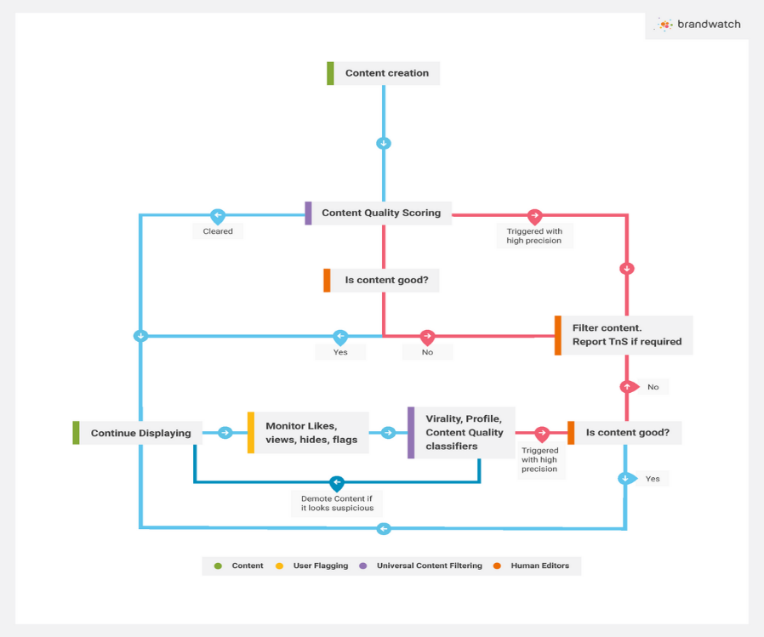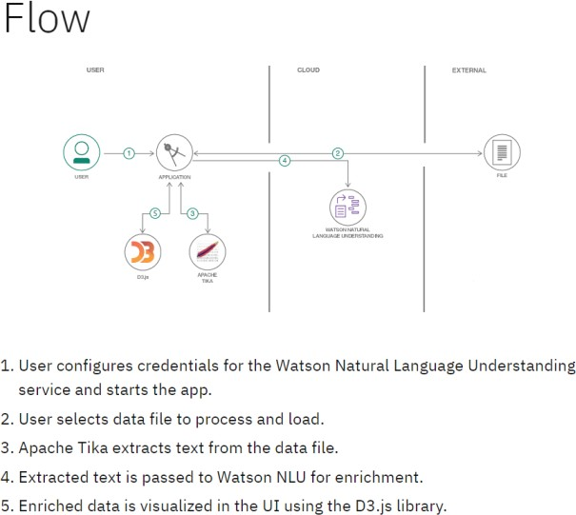

**User Stories**

Use the below template to list all the user stories for the product.

|  |  |  |  |  |  |  |
| --- | --- | --- | --- | --- | --- | --- |
| **User Type** | **Functional**  **Requirement (Epic)** | **User Story Number** | **User Story / Task** | **Acceptance criteria** | **Priority** | **Release** |
| Customer (Mobile user) | Content Creation | USN-1 | Ability to create and share informative and engaging posts, articles, videos, and other content related to their area of expertise. | I can access my account / dashboard | High | Sprint-1 |
|  | Audience Engagement | USN-2 | Capability to respond to comments, engage in discussions, and build meaningful relationships with their followers. | I can receive confirmation email & click confirm | High | Sprint-1 |
|  | Networking | USN-3 | As a user, I can register for the application through Facebook | I can register & access the dashboard with Facebook Login | Low | Sprint-2 |
|  | Login | USN-4 | As a user, I can register for the application through Gmail |  | Medium | Sprint-1 |
|  | Dashboard | USN-5 | As a user, I can log into the application by entering email & password |  | High | Sprint-1 |
|  |  |  |  |  |  |  |
| Customer (Web user) |  |  |  |  |  |  |
| Customer Care Executive |  |  |  |  |  |  |
| Administrator |  |  |  |  |  |  |
|  |  |  |  |  |  |  |
|  |  |  |  |  |  |  |
|  |  |  |  |  |  |  |